Name: _______________________________________________
Foundation Unit 15 topic test
Date:
Time: 50 minutes
Total marks available: 42
Total marks achieved: ______

Questions
Q1.
The plan, front elevation and side elevation of a solid prism are drawn on a centimetre grid.
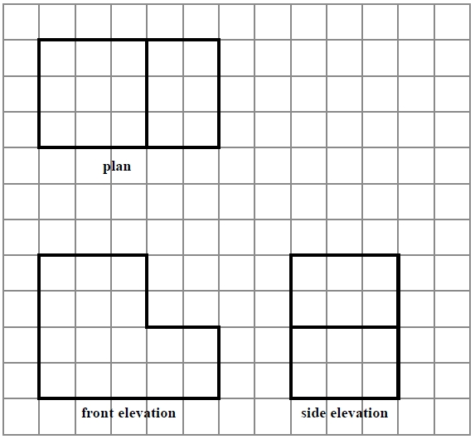
In the space below, draw a sketch of the solid prism.
Write the dimensions of the prism on your sketch.

(Total for question = 2 marks)
Q2.
Here is a pyramid with a square base.
The sloping faces are identical isosceles triangles.
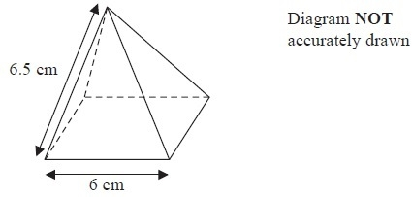
(a) Draw a full size accurate plan of the pyramid on the centimetre square grid.
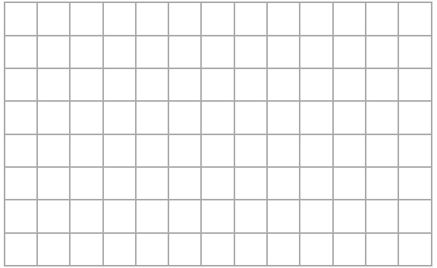
(2)

(b) Using a ruler and compasses, construct an accurate drawing of one of the triangular sloping faces of the pyramid.
(3)
(Total for Question is 5 marks)

Q3.
Here is a map.
The map shows two towns, Burford and Hightown.
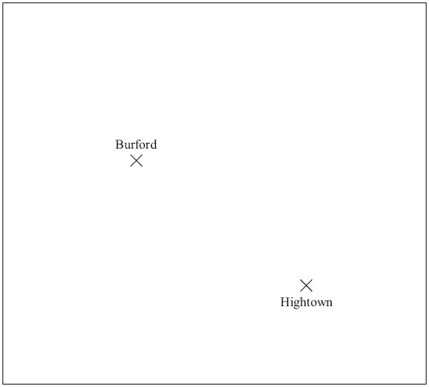
Scale: 1 cm represents 10 km

A company is going to build a warehouse.
The warehouse will be less than 30 km from Burford and less than 50 km from Hightown.
Shade the region on the map where the company can build the warehouse.

(Total for Question is 3 marks)

Q4.
The diagram shows the positions of two churches, A and B.
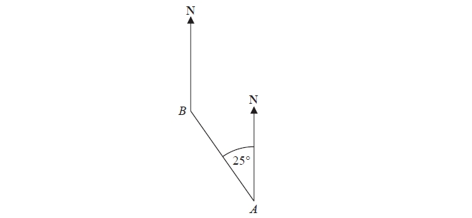
Amber says,
"The bearing of church B from church A is 025º"
Amber is wrong.
Explain why.
.............................................................................................................................................
.............................................................................................................................................
(Total for question = 1 mark)

Q5.
A model plane has a length of 17cm.
The scale of the model is 1:200
Work out the length of the real plane.
Give your answer in metres.
........................................................... metres
(Total for question = 2 marks)

Q6.
The diagram below represents two towns on a map.
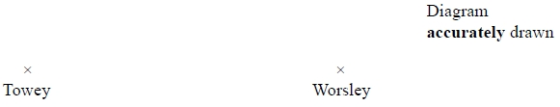
Scale: 1 cm represents 3 kilometres.
Work out the distance, in kilometres, between Towey and Worsley.
........................................................... km
(Total for question = 2 marks)

Q7.
The map shows the positions of three places A, B and C on the edge of a lake.
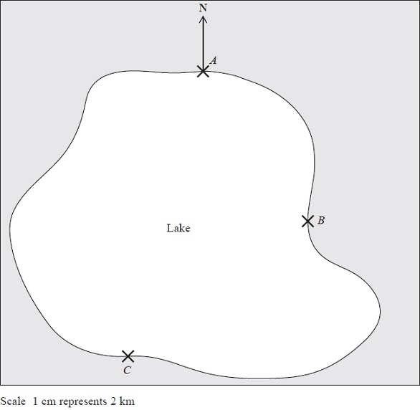
(a) Find the bearing of B from A.
........................................................... °
(1)

A ferry travels in a straight line from A to B.
It then travels in a straight line from B to C.
A speedboat travels in a straight line from A to C.
(b) How many more kilometres does the ferry travel than the speedboat?
You must show your working.
........................................................... km
(4)
(Total for Question is 5 marks)

Q8.
The diagram shows the positions of two villages, Beckhampton (B) and West Kennett (W).

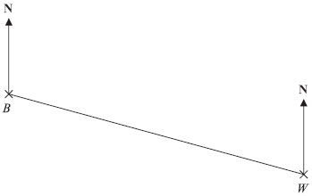
Scale: 4 cm represents 1 km.

(a) Work out the real distance, in km, of Beckhampton from West Kennett.

..............................................................................................................................................
(2)
The village, Avebury (A), is on a bearing of 038° from Beckhampton.
On the diagram, A is 6 cm from B.
(b) On the diagram, mark A with a cross (×).
Label the cross A.

(2)
(Total for Question is 4 marks)
Q9.
The diagram shows part of a map.
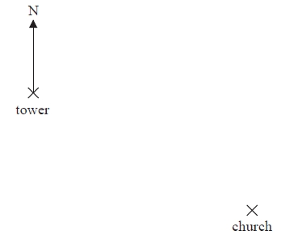
(a) Find the bearing of the church from the tower.
.........................°
(1)
The scale of the map is 1 cm represents 2.5 km.
(b) Work out the real distance between the tower and the church.
.........................km
(2)
A school is 15 km due North of the church.
(c) On the diagram, mark with a cross (×) the position of the school. Label your cross S.
(2)
(Total for Question is 5 marks)

Q10.
In the space below, use a ruler and compasses to construct an equilateral triangle with sides of length 5 cm.
You must show all your construction lines.
One side of the triangle has been drawn for you.
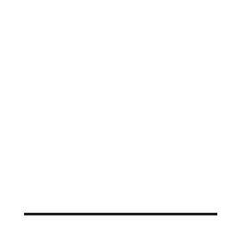

(Total for question = 2 marks)

Q11.
The diagram shows a scale drawing of a garden.
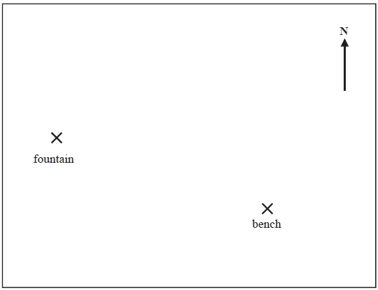
Scale: 1 centimetre represents 2 metres
(a) Work out the real distance from the fountain to the bench.
........................................................... metres
(1)
(b) Measure the bearing of the bench from the fountain.
........................................................... °
(2)
Haavi is going to plant a tree in the garden.
The tree must be
less than 7 metres from the fountain,
less than 12 metres from the bench.
(c) On the diagram show, by shading, the region in which Haavi can plant the tree.
(3)
(Total for question = 6 marks)
Q12.
This is a scale plan of a rectangular floor.
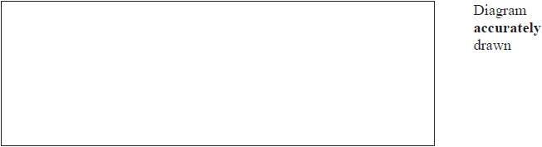
Scale: 1 cm represents 2 m
Mrs Bridges is going to cover the floor with boards. Each board is rectangular in shape.
Each board is 1.2 m long and 1 m wide.
Mrs Bridges has 150 boards.
Does she have enough boards?
You must show how you get your answer.

(Total for question is 3 marks)

Q1.
No Examiner's Report available for this question

Q2.
Few candidates understood what was required in part (a).
By far the most common answer was to see the net of the shape drawn. Those that knew to draw a 6 cm by 6 cm square lost the final mark as they did not draw in the diagonals of the square for a completely correct plan. Others drew the correct square with one or two triangles as well. Part (b) was done far more successfully with nearly all candidates scoring at least 1 mark for one accurately drawn line. Many others went on to correctly draw the required triangle within the tolerances given.

Q3.
This question was very poorly answered, with only a few candidates understanding the need to construct loci about the given points. Those who did were usually accurate. A few candidates clearly realised arcs were needed but had no compasses. A few constructed the arcs correctly but shaded the complement of the intersection.

Q4.
No Examiner's Report available for this question

Q5.
No Examiner's Report available for this question

Q6.
No Examiner's Report available for this question

Q7.
Candidates often struggle with bearings and this year was no exception with candidates being unsure of which angle to measure. Part (b) was tackled well with most candidates measuring at least one of the distances correctly in cm and then converting this correctly to km scoring at least 2 marks. Many then went on to produce a final answer between 7 and 9 from correctly measuring all 3 distances.

Q8.
In part (a), the correct measurement of 10 cm was usually seen or implied but with subsequent errors in the use of scale factor, including multiplication rather than division by 4. However, an incorrect answer of 2.2 km was common and with no supporting argument, showing clearly how it had been obtained, no marks were awarded. In part (b), the vast majority of candidates picked up 1 mark for plotting a point 6 cm from B (quite often actually on the line BW), but very few scored the second mark for a correct bearing. This clearly is a topic that candidates find difficult at this level. Even when knowledge of bearings was apparent, accuracy in the use of a protractor was often poor (or missing). Many took the bearing from line BW.

Q9.
Throughout this question, students appeared more confident with scale drawing than with bearings. In part (a) where a bearing was measured only about 40% gave the correct 120° with some answers of 60° blank responses indicated that some may not have been equipped with a protractor.
The vast majority of students picked up some marks on parts (b) and (c) but the main issue was one of accuracy. In part (b) the distance on the map had to be measured to within 2mm but many students were 3 mm away from the correct value.
Similarly, students who appeared to know what to do in part (c) lost one or even both marks due to a lack of care with their actual drawing. Again, students need to be aware that the tolerances allowed here were ± 2mm and ± 2°

Q10.
This question was well attempted and many students gained full marks having drawn an equilateral triangle with the correct construction arcs. Some students were clearly not constructing the triangle using compasses and so could only gain a maximum on 1 mark for drawing an equilateral triangle. It was very rare to award 1 mark for seeing a correct construction arc without an attempt at drawing the triangle. It was obvious that some students were drawing free hand.

Q11.
Students were most successful in part (a) and almost all were able to measure the distance between the bench and the fountain to gain the mark. Weaker students forgot to multiply their measurement by 2.
In part (b), students usually either gained the full 2 marks or 0, as those that did not understand bearings rarely drew anything on the diagram. There were however, a few that had drawn in the bearing then incorrectly measured the angle leading to an answer in the 70s.
Students attempted part (c) well and often, even if not worthy of any marks, were still using compasses to draw arcs. Many gained full marks or two marks having shaded the wrong region. Only the very weakest students were shading a square or irregular shaped region, though even these regions were shaded in-between the fountain and the bench, indicating some understanding of the problem even if they scored 0 marks.

Q12.
No Examiner's Report available for this question

Mark Scheme
Q1.
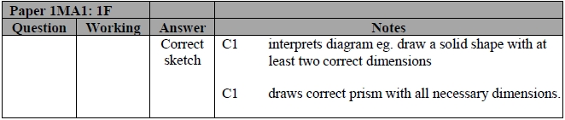

Q2.
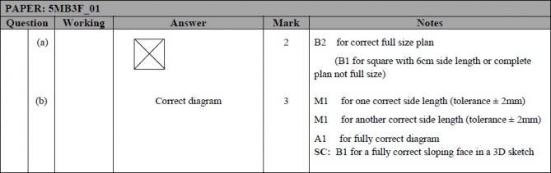

Q3.
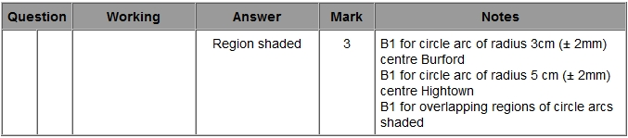

Q4.
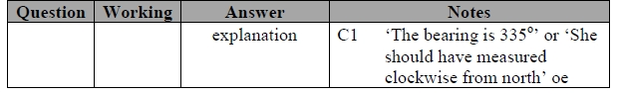

Q5.
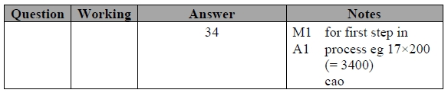

Q6.
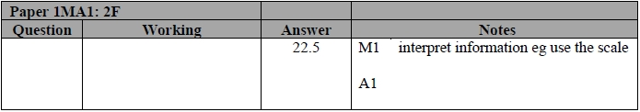

Q7.
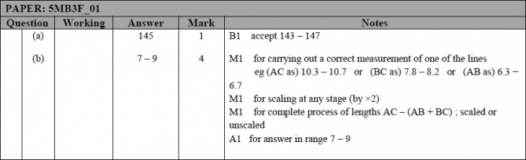

Q8.
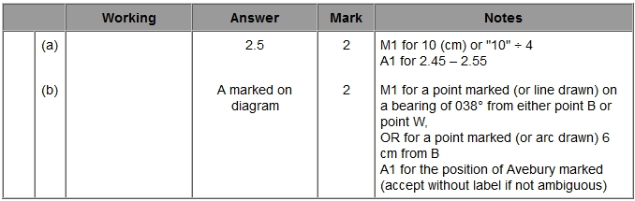

Q9.
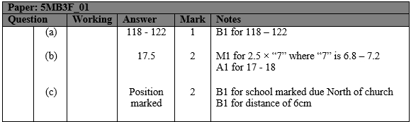

Q10.
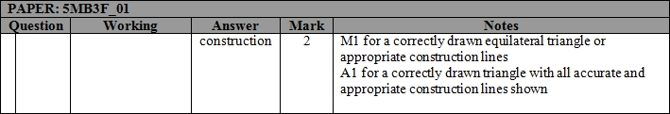

Q11.
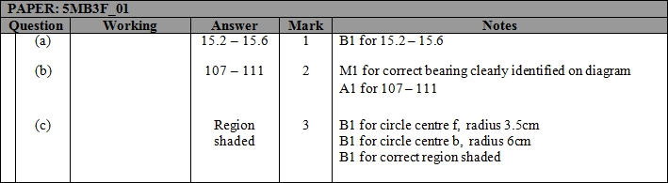

Q12.
